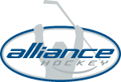 | 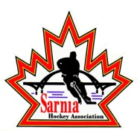

RE: ALLIANCE Hockey Respect in Sport Parent Program Implementation

Dear Parents/Guardians;

In an ongoing effort to foster a safe and enjoyable environment for our athletes in our great game, ALLIANCE Hockey is implementing a plan to ensure that ALLIANCE Hockey becomes a Respect integrated organization.

Effective August 31, 2015, at least one parent/guardian of each player with a 2004 and younger birth year who participate in a League registered in the ALLIANCE will be required to complete the online Respect in Sport Parent Education Program as a condition of their child’s participation.

The Respect in Sport Parent Program is a proactive, educational program that empowers parents with the tools to ensure the game is enjoyable and respectful for themselves, their children and all other stakeholders in the game.

Sarnia Hockey Association will be responsible for implementing these requirements as established by ALLIANCE Hockey and requires your support and cooperation with ensuring the completion of this certification. Although ALLIANCE Hockey has identified a deadline for compliance, many member Associations have chosen to be proactive and have set earlier deadlines for compliance. ALLIANCE Hockey supports Member Associations who have opted to adopt this proactive approach.

Please ensure that you provide feedback as requested upon completion of the program, to provide your insights on optimizing program content, and system functionality.

Thank you for your commitment to the safety, enjoyment and success of your child, and all ALLIANCE Hockey participants.

ALLIANCE Hockey
71 Albert Street
Stratford, ON N5A 3K2
E: alliance@alliancehockey.com
P: 519-273-7209

