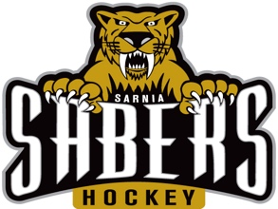
Sarnia Hockey Association

House League Team Equipment Sign-out

Team | Lock/Key ID | Equipment | Size | Number Issued | Number Returned
 |  | Sweaters
 |  | Socks
 |  | Goalie Pads
 |  | Goalie Chest Protector
 |  | Goalie Catcher
 |  | Goalie Blocker
 |  | Goalie Neck Protector
 |  | Neck Protector Lace
 |  | Goalie Stick
 |  | Goalie Stick Tape
 |  | Goalie Equipment Bag
 |  | Puck Container (Crate)
 |  | Pucks (Black) | 6 oz.
 |  | Pucks (Blue) | 4 oz.
 |  | Player of the Game Pucks
 |  | Pylons

Coach Name (Print): ______________________________

Coach Signature: ______________________________

Date Signed Out: ______________________________

Date Returned: ______________________________

