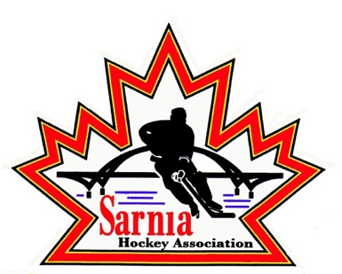

Sarnia Hockey Association
Player Concussion Code of Conduct

Respect yourself:
• I will wear the proper equipment and wear it correctly.
• I will develop my skill and body strength so that I can play the game to the best of my abilities.
• I understand that a concussion is a serious brain injury that has both short- and long-term effects.
• I understand that I don’t need to lose consciousness to have had a concussion.
• I understand that any blow to the head, face, or neck, or a blow to the body which causes a sudden jarring of the head may cause a concussion.
• I understand that if I suspect I might have a concussion I should stop playing the sport immediately.
• I understand that continuing to play with a suspected concussion increases my risk of more severe, longer lasting concussion symptoms, as well as increases my risk of other injury.
• I will not hide my symptoms. I will tell my coach, trainer, parent, or other responsible person if I am concerned I have had a concussion and/or experience any signs and symptoms of concussion following a collision.
• I understand I will not be able to return to play following a collision where I experience signs and symptoms of concussion.
• I understand I will have to be cleared by a physician or qualified medical professional, preferably one with experience in concussion management, prior to returning to play.
• I understand I will have to follow the 6-step Return to Play guidelines when returning to activity.
Respect Others:
• I will respect the rules of the game.
• I will respect my opponents and play fair.
• I will not fight or attempt to injure anyone on purpose.
• I will respect my coaches, trainers, parents and the medical professionals and any decisions made with regards
to my health and safety.

